Introduction

There are multiple typhoon forecasting systems which provide forecast information for typhoon track, wind speed and other variables which describe the characteristic of an upcoming typhoon. These forecasting systems relay mainly on numerical models, each modeling system have different spatial scale, time step, model structure, and other parameters which leads to differences in model outputs like forecasted windspeed and Typhoon Track. For typhoon FBF system will be triggered by forecast information from forecasting systems, we need to assess the skill of the different forecasting systems by comparing historical forecast information against observation. In this forecast skill assessment we compared performance of 10 models from different forecasting agencies, which are all mandated by world meteorological agency(WMO) to issue a forecast, against observation.

Data and Methodology

For forecast skill assessment we used the following datasets:

1. Best track data and

Best Track data was downloaded from Joint Typhoon Warning center(JTWC). This data set cover the period 2005- 2017, documentation on the datasets can be found [here](http://www.metoc.navy.mil/jtwc/jtwc.html?western-pacific)

1. Forecast data for historical events.

We assessed forecasting skill of a typhoon forecasting system by comparing forecast issued during historical events against best track dataset. For the North western Pacific basin, which include the Philippine, there are multiple agencies which provide typhoon forecast information. The forecast information is based on numerical model simulations, table 1 recaps WMO sanctioned typhoon forecast models for the north pacific region.

**Table 1 Available short term Forecasts. Historical data was accessed via THORPEX Interactive Grand Global Ensemble (TIGGE) Model Tropical Cyclone Track Data.**

|  |  |  |  |
| --- | --- | --- | --- |
| Group | Basin | Model Type/model names | REMARK |
| Tropical Storm Risk.com | N Atlantic  NW Pacific (JTWC)  NW Pacific (JMA) | Statistical for Atlantic basin and  JTWC JMA for North west pacific basin |  |
| European Centre for Medium Range Weather Forecasts (ECMWF) | Global | Dynamic  ECMWF |  |
| Japan Meteorological Agency (JMA) | Global | Dynamic JMA-TEPS,JMA-WEPS and JMA-GEPS (since 2017) |  |
| Meteo-France | Global | Dynamic  PEARP |  |
| United Kingdom Met Office (UKMO) | Global | Dynamic  MOGREPS-G and MOGREPS |  |
| National Centers for Environmental Prediction (USA) and Meteorological Service of Canada | Global | Dynamic  CENS and GEFS |  |

Methodology

In our skill assessment in typhoon track forecasting we compared position of typhon center against observation, for each lead time

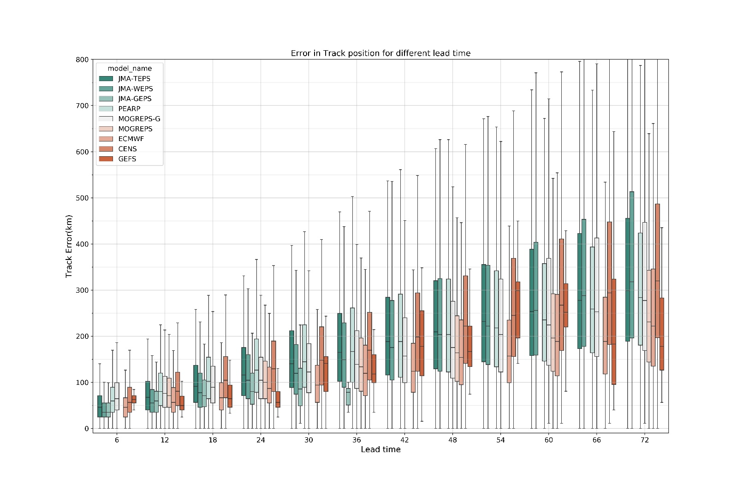

Result

Based on Typhoon track forecast skill assessment ECMWF, GEFS JMA-GEPS perform better than other products. JMA-GEPS could be the same model used by PAGASA.

|  |  |  |  |  |  |  |  |
| --- | --- | --- | --- | --- | --- | --- | --- |
| Institution | Link | Model | Update Interval(hour) | Lead Time (days) | 24h Forecast Accuracy (%) | 48h Forecast Accuracy (%) | 72h Forecast Accuracy (%) |
| Meteo France |  | Global (PEARP) |  |  | - | - | - |
| UK-MO |  | Global (MOGREPS) |  |  |  |  |  |
| European Centre for Medium Range Weather Forecasts  (ECMWF) | [https://www.ecmwf.int/en/forecasts/charts/tcyclone/](https://eur03.safelinks.protection.outlook.com/?url=https%3A%2F%2Fwww.ecmwf.int%2Fen%2Fforecasts%2Fcharts%2Ftcyclone%2F&data=02%7C01%7CATeklesadik%40redcross.nl%7Cc690b6580bfe4765f27208d716826741%7Cd3ab97906ae24bd8aa5e02864483e7c7%7C0%7C0%7C637002621659520427&sdata=uRJ89L3Ndn9TE0BJGxkadxflymJIYsNcjFxiadHNdX4%3D&reserved=0) | global | 12 | 10 | - | - | - |
| National Centers for Environmental Prediction  (NCEP) |  | Global  (CENS and GEFS) |  |  |  |  |  |
| Joint Typhoon Warning center  (JTWC) | [http://www.metoc.navy.mil/jtwc/](https://eur03.safelinks.protection.outlook.com/?url=http%3A%2F%2Fwww.metoc.navy.mil%2Fjtwc%2F&data=02%7C01%7CATeklesadik%40redcross.nl%7Cc690b6580bfe4765f27208d716826741%7Cd3ab97906ae24bd8aa5e02864483e7c7%7C0%7C0%7C637002621659520427&sdata=HfQzXv5mydXON%2BOi532j6m3bqy0b5lyoWKA2Iq%2B6OUY%3D&reserved=0) | Regional | 6 | 5 | - | - | - |
| Japan Meteorological Agency  (JMA) | [http://www.jma.go.jp/jma/indexe.html](https://eur03.safelinks.protection.outlook.com/?url=http%3A%2F%2Fwww.jma.go.jp%2Fjma%2Findexe.html&data=02%7C01%7CATeklesadik%40redcross.nl%7Cc690b6580bfe4765f27208d716826741%7Cd3ab97906ae24bd8aa5e02864483e7c7%7C0%7C0%7C637002621659520427&sdata=TtihWM5ZsgWnzVJ12g9sLgUPS9yvCwHPC2gnIcW1I3w%3D&reserved=0) | Global (GEPS) & Regional | 6 | 5 | - | - | - |
| PAGASA | [https://www1.pagasa.dost.gov.ph/](https://eur03.safelinks.protection.outlook.com/?url=https%3A%2F%2Fwww1.pagasa.dost.gov.ph%2F&data=02%7C01%7CATeklesadik%40redcross.nl%7Cc690b6580bfe4765f27208d716826741%7Cd3ab97906ae24bd8aa5e02864483e7c7%7C0%7C0%7C637002621659530416&sdata=8Gi%2FxcBxkBmTJan9a6P6%2Fm0AtyweL0saRIqqhN9%2B8OI%3D&reserved=0) | Local | 3 | 5 | 54 | 63 | 63 |
| Weather Philippines Foundation  (WPF) | [https://weatherph.org/](https://eur03.safelinks.protection.outlook.com/?url=https%3A%2F%2Fweatherph.org%2F&data=02%7C01%7CATeklesadik%40redcross.nl%7Cc690b6580bfe4765f27208d716826741%7Cd3ab97906ae24bd8aa5e02864483e7c7%7C0%7C0%7C637002621659530416&sdata=qeUhYCIemRiUmgYOHK9zjyBjK8DWba%2BxjmKzE%2FU2FoE%3D&reserved=0) | Local | 6 | 5 | 63 | 72 | 72 |